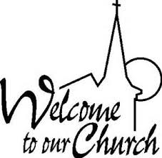

**Welcome Service July 7, 2024**

**Please join us for worship and welcome Pastor Raj as our new spiritual leader.**

**Dates To Remember**

**June 11, 2024 – Trustees Meeting MRUMC 6:30PM**

**June 16, 2024 – “Breakfast Church” 9:00AM MRUMC**

**June 18, 2024 – Administrative Council Meeting**

**MRUMC 6:30PM**

**June 22, 2024 – Combined LUMC & MRUMC Church Picnic 1:00-4:00PM at Lumberton United Methodist Church**

**Please bring a side dish and or a dessert to share!!**

**\*\*NOTE: No “Worship First” Saturday Evening Service**

**July 6, 2024 MRUMC**



**Welcome Service July 7, 2024**

**Please join us for worship and welcome Pastor Raj as our new spiritual leader.**

**Dates To Remember**

**June 11, 2024 – Trustees Meeting MRUMC 6:30PM**

**June 16, 2024 – “Breakfast Church” 9:00AM MRUMC**

**June 18, 2024 – Administrative Council Meeting**

**MRUMC 6:30PM**

**June 22, 2024 – Combined LUMC & MRUMC Church Picnic 1:00-4:00PM at Lumberton United Methodist Church**

**Please bring a side dish and or a dessert to share!!**

**\*\*NOTE: No “Worship First” Saturday Evening Service**

**July 6, 2024 MRUMC**